HURTWOOD HOUSE

Anti-Bullying Policy

Reviewed | By | Last reviewed | Last modified
Annually | SMT | May 2024 | May 2024

BULLYING OF ANY KIND IS ALWAYS UNACCEPTABLE AND WILL NOT BE TOLERATED

Aims and Objectives

- The aim of the school’s anti-bullying policy is to emphasise to all students, parents/guardians and staff that bullying is always unacceptable.

- We wish to encourage an environment and school community characterised by warmth, friendliness and tolerance, where independence is celebrated and respected, and individuals can flourish without fear.

- Every student has the right to be safe and happy, to enjoy his/her learning and leisure time free of intimidation and to be protected when feeling vulnerable.

- Bullying concerns will be dealt with quickly and sensitively.

- We have a zero tolerance for bullying.

Statement of Intent

- At Hurtwood House, our community is based upon respect, good manners and fair play. We are committed to providing a safe and caring environment that is free from disruption, violence and any form of harassment so that every one of our students can develop his or her full potential. We expect our students to treat members of staff with courtesy and co-operation so that they can learn in a relaxed, but orderly, atmosphere. All students should care for and support each other.

- Hurtwood prides itself on its respect and mutual tolerance. Ours is a diverse community, with students from a variety of cultural, religious and ethnic backgrounds. Some students require additional support and help. Parents/guardians have an important role in supporting Hurtwood in maintaining high standards of behaviour. It is essential that there are consistent expectations of behaviour at school, online and at home and that the School and parents/guardians co-operate closely together.

- Bullying, cyberbullying, harassment, victimisation and discrimination will not be tolerated. We treat all our students and their parents fairly and with consideration and we expect them to reciprocate towards each other, the staff and the School. Any kind of bullying is unacceptable (including cyberbullying, prejudice-based and discriminatory bullying) and any instances of bullying will be recorded and, where appropriate, will result in disciplinary action in accordance with the School’s Discipline and Behaviour Policy. A bullying incident will be treated as a child protection concern where there is reasonable cause to suspect that a child is suffering, or is likely to suffer, significant harm. The school's child protection procedures in the Child Protection and Safeguarding Policy will be initiated.

Definition of Bullying

- Bullying may be defined as behaviour by an individual or group, repeated over time, that intentionally hurts another individual or group either physically or emotionally. It may take many forms, including physical (including any threat of or use of violence of any kind), sexual (including the sharing of nudes/semi-nudes), verbal (including cyberbullying via text messages, email, social media, gaming, or other instant messages, and can include the use of images and video), and/or emotional (including by excluding, being sarcastic, name-calling, tormenting or spreading malicious rumours). It can involve manipulating a third party to tease or torment someone, or actions that fall short of direct participation, where someone encourages others to bully, or joins in with laughing at a victim. Bullying is often hidden and subtle. It can also be overt and intimidating, and often involves an imbalance of power between the perpetrator(s) and the victim(s) whether that be a physical, psychological (knowing what upsets someone), or intellectual imbalance, or by the perpetrator(s) having access to the support of a group, or the capacity to socially isolate the victim(s).

- Bullying can sometimes amount to peer on peer abuse, which is defined as abuse by one or more students against another student. It can be standalone or as part of wider abuse and can happen both inside and outside of school, and online. Further information about peer on peer abuse, including the procedures to follow when an incident on peer on peer abuse is reported can be found in the School's [Child Protection / Safeguarding policy].

- Bullying is often motivated by prejudice against particular groups, and may involve actions or comments regarding a person's race, religion, sex, gender, sexual orientation, special education needs or disabilities (SEND) or certain health conditions, or because of a child's familial circumstances, such as they are adopted, in care or that they have caring responsibilities. Bullying may be motivated by actual differences between children, or perceived differences. For example, bullying can still be homophobic if directed towards a child that is perceived to be gay, whether or not this is the case.

- Bullying can happen anywhere and at any time and can involve anyone - students, other young people, staff, and parents.

Response to Bullying

- Bullying of students and school staff, whether by students, parents or other members of staff is covered by this policy and will not be tolerated.

- We always treat bullying very seriously. It conflicts sharply with the school’s policy on equal opportunities, as well as with its social and moral principles.

- When incidents of bullying do occur, they are dealt with quickly and taken seriously. The School will never dismiss or downplay bullying as banter or horseplay, and all reported incidents of bullying will be dealt with by staff in accordance with this policy. Staff will reassure any victim(s) that they are being taken seriously and that they will be supported and kept safe.

- Students who are victims of bullying will always be supported and will be reassured that they will be kept safe. Students who have engaged in bullying behaviour will be subject to appropriate disciplinary sanction and will also, where possible, be supported in learning different ways of behaving and offered support for their own circumstances, where appropriate.

- Bullying which occurs on School trips, online, or outside of the School's premises will not be tolerated any more than bullying on School premises. Staff will, where appropriate, discipline students for misbehaviour online, outside School premises and outside School hours.

Signs of Bullying

- Changes in behaviour that may indicate that a student is being bullied include:

- Unwillingness to return to school
- Displays of excessive anxiety, becoming withdrawn or unusually quiet
- Failure to produce work, or producing unusually bad work, or work that appears to have been copied, interfered with or spoilt by others
- Books, bags and other belongings suddenly go missing, or are damaged
- Change to established habits (e.g. giving up music lessons, change to accent or vocabulary)
- Psychological damage and diminished levels of self confidence
- Frequent visits to the Health Centre with symptoms which may relate to stress, such as stomach pains, headaches
- Unexplained cuts and bruises
- Frequent absence, erratic attendance, late arrival to class
- Choosing the company of adults rather than peers
- Displaying repressed body language and poor eye contact
- Difficulty in sleeping, experiences nightmares
- Talking of suicide or running away

Although there may be other causes for some of the above symptoms, a repetition of, or a combination of these possible signs of bullying should be investigated by parents and teachers, and reported/recorded as appropriate in accordance with this policy.

Preventative Measures

- We take the following preventative measures in order to create an environment that prevents bullying from becoming a problem at the School:

- We ensure that the school policy on bullying is freely available to parents/guardians, students and members of staff.
- We promote an ethos of good behaviour where students treat each other with respect at all times, inside and outside of school.
- Our Life Skills programme is structured to give students an awareness of their social and moral responsibilities as they progress through the school. The programme and House structure is designed to enforce the message about community involvement and taking care of each other.
- In the first week of the academic year, each Housemaster/mistress addresses their house regarding bullying and other potential concerns, and specifically tells students whom they should inform if they are being bullied, or are worried that another student is being bullied. In addition, The Deputy Head Students meets all new students in the first week to establish behaviour and discipline expectations for their time at Hurtwood, and this the zero tolerance of and response to bullying.
- All our students are encouraged to tell a member of staff at once if they know that bullying is taking place. Every member of staff is aware of how to respond to such allegations.
- All reported incidents are recorded – to enable patterns to be identified - and investigated at once. We always monitor reported incidents.
- We have a strong and experienced team of staff who are equipped to handle any incidents as an immediate priority, and are alert to possible signs of bullying.
- Staff are always on duty at times when students are not in class and patrol the school site, particularly areas where bullying might occur. They are aware to be alert to students who may be vulnerable and at risk from bullying and to inappropriate language or behaviour.
- In boarding houses, there are strong teams of tutors supporting the Housemaster/mistress, who act in loco parentis. The informal house environment is important in reinforcing a student’s standards and values, providing the opportunity for friendly, informal discussion of matters of concern to the individual student outside the formal classroom. We encourage close contact between the Housemaster/mistress and parents/guardians, and would always make contact if we were worried about a student’s well-being.
- All our boarding houses display advice on where students can seek help, including details of confidential help lines and web sites connecting to external specialists.
- All students have access to a telephone helpline, enabling them to call for support in private.
- We have banned initiation ceremonies designed to cause pain, anxiety or humiliation.
- We reserve the right to investigate incidents that take place outside school hours, on school visits and trips and that occur in the vicinity of the school, involving our students.
- We welcome feedback from parents and guardians on the effectiveness of our preventative measures.
- It is a requirement that all members of staff are familiar with this policy and its procedures. Each member of staff acknowledges that they have re-read the policy on an annual basis.
- We will raise awareness of staff through training, so that the principles of the School’s policy are understood, legal responsibilities are known, action is defined to resolve and prevent problems, and sources of support are available. Where appropriate, the School may invest in specialised skills to understand the needs of students including those with SEND and lesbian, gay, bisexual and transgender students (LGBTQ+).

Cyber-Bullying

- Cyber-bullying can be defined as "the use of information and communication technologies to support deliberate, repeated, and hostile behaviour by an individual or group that is intended to harm others" (Belsey, http://www.cyber-bullying.org/). It is an aggressive, intentional act often carried out repeatedly over time, and often against a victim who cannot easily defend himself/ herself. The School acknowledges that cyber-bullying may take place inside School, outside of School and at any time of the day.

- Cyber-bullying could involve communications by various electronic media, including for example:

  - Texts, instant messages or calls on mobile phones;
  - The use of mobile phone camera images to cause distress, fear or humiliation;
  - Posting threatening, abusive, offensive or humiliating material or comments on websites (including blogs, personal websites and social networking sites such as Facebook, Instagram, Twitter or YouTube);
  - Using e-mail to message others in a threatening or abusive manner; or
  - Hijacking/ cloning e-mail accounts.

- The School acknowledges that cyber-bullying may take many different forms including: cyber-stalking, exclusion or peer rejection, impersonation, unauthorised publication of private information or images, encouraging derogative comments on online platforms, the consensual and non-consensual sharing of nude and semi-nude images and/or videos, upskirting and sexting. It may also include online sexual harassment such as sharing of unwanted explicit content, unwanted sexual comments and messages, including, on social media, sexualised online bullying and sexual exploitation; coercion and threats.

Prevention of Cyber-Bullying

- In addition to the preventative measures described above, Hurtwood House:

- Expects all students to adhere to its AUP for the safe use of the internet. Certain sites are blocked by our filtering system and our IT Department monitors students’ use.
- May impose sanctions for the misuse, or attempted misuse of the internet.
- Issues all students with their own personal school email address.
- Offers guidance on the safe use of social networking sites.
- Offers guidance on keeping names, addresses, passwords, mobile phone numbers and other personal details safe.

- Further details, including the school’s position on the use of the internet, are given in our e-Safety Policy and Acceptable Use Agreement.

- The Education Act 2011 gives teachers stronger powers to tackle cyberbullying by providing specific powers to search for and, if necessary, delete inappropriate images (or files) on electronic devices, including mobile phones. The separate policy – Behaviour and Discipline, Appendix 2 Searching and Confiscation - should be referred to.

Encouragement to Tell

- It is important that we create an atmosphere in the school where students who are being bullied, or others who know about it, feel that they will be listened to and believed, and that action will be swift, effective and sensitive.

- If a student is being bullied he/she should tell an adult – a teacher or tutor or Housemaster/mistress or the Deputy Head – Students (DHS) or a school nurse or the independent listener or ask his/her friends to tell an adult. If a student knows of another student being bullied, he/she should tell an adult. Every member of staff at Hurtwood House who suspects any form of bullying will inform the appropriate member of senior staff immediately.

Keeping quiet protects the bully and implies that the harassment can continue.

Procedures for dealing with Bullying Incidents

- If an incident of bullying is reported, the following procedures are adopted. A modified procedure may be adopted:

- The member of staff to whom it was reported or who first discovers the situation, will control the situation, reassure and support the students involved.
- He or she will inform an appropriate member of the Senior Management team as soon as possible.
- The member of staff will calmly explain the range of disciplinary measures that are potentially involved.
- The victim will be interviewed, sensitively, on his or her own and asked to write an account of events.
- The alleged bully, together with all others who were involved, will be interviewed individually and asked to write an immediate account of events.
- The incident will be recorded by the DHS, or in his absence the Deputy Head – Personnel (DHP), in the Incident Database.
- The Housemaster/mistress will be informed. In very serious incidents, the Headmaster will be informed.
- The victim may be interviewed at a later stage by a member of SMT, separately from the alleged perpetrator. It will be made clear to him or her why revenge is inappropriate. He or she will be offered support to develop a strategy to help him or herself.
- The alleged bully may be interviewed at a later stage by a member of SMT, separately from the victim, and it will be made clear why his or her behaviour was inappropriate and caused distress. He or she will be offered guidance on modifying his or her behaviour, together with any appropriate disciplinary sanctions.
- The parents/guardians of all parties will be informed and may be invited into school to discuss the matter. Their support will be sought. Parents have an important role to play in reporting bullying, including cyber-bullying, when they become aware of it as bystanders.
- A way forward, including disciplinary sanctions and counselling, will be agreed.
- This should recognise that suitable support is needed both for students who are being bullied and for students who bully others, as well as dealing with appropriate disciplinary measures. Every effort is made to resolve the problem through counselling of both parties and in certain circumstances sanctions may be applied, including the use of exclusion.
- A meeting involving all the parties, with close staff supervision, could be considered helpful in developing a strategy for all concerned to close the episode.
- A monitoring and review strategy will be put in place.
- In very serious and persistent cases, and only after the Headmaster has been involved, it may be necessary to make a report to the Police or to the Social Services. However, it is the policy of Hurtwood to attempt to resolve such issues internally under the school’s own disciplinary procedures, unless the matter is of such gravity that a criminal prosecution is likely. Note: A bullying incident will be treated as a child protection concern when there is reasonable cause to believe that a student is suffering or likely to suffer significant harm.
- In a very serious case or a case of persistent bullying, a student may, after a fair hearing, be required to leave the school permanently in accordance with the school's policy on expulsion, removal and review.

Complaints

- If a victim or his/her parents are not satisfied with the action taken by the School, they should be advised to make a formal complaint, according to the School's published complaints procedure.

Monitoring and Review

- The School will record all incidents of reported bullying in accordance with this policy.
- This policy will be reviewed annually by the DHS and the SMT to assess its effectiveness, and will be updated as necessary. It will be reviewed after any serious bullying incidents. In undertaking the review the DHS will take into account the results of any monitoring of bullying incidents, as well as any changes in legislation or statutory guidance and other relevant information gathered (such as through a bullying survey).
Authorised by | resolution of the Partners  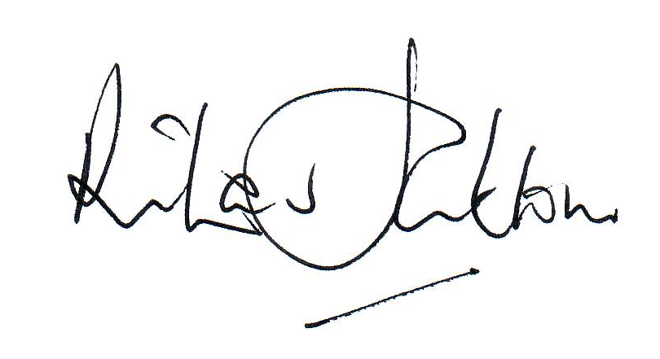  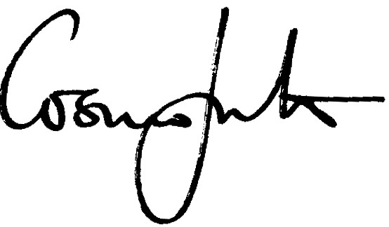
Date | 18th June 2024

Effective date of the policy | 1st September 2024
Circulation | Partners / all staff / parents / students on request  Published on the school website, in the Termly Student Diary and the Student and Parent Handbook
Status | Complies with requirements the Education (Independent School Standards) (England) Regulations 2014, Boarding schools: national minimum standards (Department for Education (DfE), 2022), Preventing and tackling bullying (DfE, July 2017) and Keeping Children Safe in Education (DfE Sept 2024)

