HURTWOOD HOUSE

Admissions Policy

Reviewed | By | Last reviewed | Last modified
Annually | SMT | May 2024 | May 2024

Admissions Policy and Entrance Requirements

Hurtwood House is a mixed-ability, inclusive learning community whose main principle governing student admission is whether the student will benefit from the type of education that the school offers. The school is committed to ensuring that all students accepted will be successful and happy within the high academic standards and busy extra-curricular environment that are provided. In making admission selection, the school does not discriminate on the grounds of gender, race, religious faith or disability.

There are about 180 places available each academic year with on average 65 for boys and 115 for girls. The exact numbers can vary from year to year and are generally limited by the number of boarding places available by gender for any given year. There is strong competition for places.

Selection is based largely on the impressions formed at interview and on the reference provided by an applicant’s previous school. The school will look for students who have a clear idea of what they want to achieve and those who are hardworking, mature and ready to take full advantage of the opportunities that Hurtwood has to offer its students.

If, after interview, parents decide that they would like their son or daughter to be considered for selection at Hurtwood House, they should write to the school enclosing the application form and the registration payment. There are several options at this stage:

- Students may be told immediately that they have not been accepted, in which case the registration payment will be returned immediately;

- Some students may be offered an immediate place, subject to their reference;

- the remainder of applicants will be placed into a “pool” of potential students for selection later in the year.

(The school prefers not to discuss the various options at interview in front of the student, particularly if there is any doubt about their suitability).

An applicant’s present academic record is significant as the school has high academic standards to maintain, but this is only one criterion for selection. There is no minimum level of entrance requirement, but students will only be accepted on to courses where they have shown the necessary skills through previous assessment achievements. Most importantly, the school will accept students who are felt will make a positive contribution to the community. Character, willingness, cheerfulness, creativity and enthusiasm are all important qualities that will be sought.

It is a standard courtesy that a written reference from the student’s current school is obtained before a definite place can be offered at another school. As well as ensuring that everyone concerned is kept in the picture about potential student moves, it also serves to confirm or contradict the impressions that have been gained at the interview stage. It will usually be requested at the same time as a completed application form is received by the school, but it can be delayed until parents have informed the school directly of their intention to move their child. (Parents must notify the school in writing at the time of making the application if they would like the school to delay writing for the reference).

Waiting List

If there are no places immediately available, a successful applicant will be offered a place on a waiting list and will be contacted should a suitable place become available at a later date.

Appeals

All applications receive full consideration prior to reaching a decision based on the criteria cited above. However, parents of unsuccessful applicants have the right of appeal against the decision if they notify the school in writing within two weeks of receiving notification that their son’s or daughter’s application has not been successful, clearly setting out the grounds for appeal. This letter should be addressed to the Headmaster. The appeal will be heard by the Appeal Committee, consisting of three representatives from the Partners and the senior management team. Parents will be notified of the decision of the Appeal Committee by letter within 3 weeks of receiving the parents’ grounds for appeal letter.

Scholarships

Scholarships are available for Performing Arts and for Mathematics and Science students.

Performing Arts

The school offers a limited number of two-year A-Level Performing Arts scholarships - one at 50% of the fees, two at 25% of the fees and several at 10% of the fees. The major scholarships are awarded to students auditioning in all three of the disciplines – acting, singing and dance. The scholarships of 10% of the fees will be awarded to students auditioning in the following disciplines:
- Acting and dance
- Acting and singing
- Acting only.
The school does not expect students of this age to have received any formal vocational training but is looking for evidence of outstanding talent and natural skills and for students who would make a positive contribution to the Hurtwood Theatre during their time here.

Scholarships are awarded for the full two-year period of the student's A-Levels but will be subject to review at the end of the first year. Successful candidates will not necessarily be expected to take A-Level Theatre Studies as part of their A-Level programme but they are expected to contribute to all major school productions.

Before auditioning for one of these scholarships, it is necessary for students to come for an interview. Once an interview has been undertaken, the scholarship application form should be completed and returned to the school. References will be required on receipt of the completed application form.

Mathematics / Science Scholarships

The school offers several A-Level Maths / Science scholarships. There are a number at 10% of the fees and at 20% of the fees, and they would be awarded to particularly gifted students for the full two-year period of their A-Levels. The successful candidates would be expected to take one or more of the A-Level Sciences and / or A-Level Mathematics as part of their A-Level programme.

Scholarship procedure
Scholarships will be awarded to candidates based on performance in our scholarship examination in the Sciences and Mathematics, on an interview at the school and on a reference from the relevant teacher or teachers at the student’s present school. Students may sit a general paper covering Mathematics, Physics, Chemistry and Biology or they may choose to specialise in one subject only. It would be helpful if applications were supported by a reference from the relevant teacher or teachers at the student’s current school.

Bursaries

Hurtwood House offers a limited number of bursaries to local families on Day Fees.
Admissions Procedure

ENQUIRY
from parents

PROSPECTUS
sent to parents
REQUEST for INTERVIEW from parents
Confirmation of INTERVIEW and QUESTIONNAIRE
sent to parents

INTERVIEW
Parents send APPLICATION FORM with DEPOSIT
Application form acknowledged and REFERENCES sent for
School makes a decision based on interview and references
Parents return completed ACCEPTANCE FORM
School DOES NOT OFFER place and sends letter informing parents of decision
School OFFERS place and sends TERMS & CONDITIONS and ACCEPTANCE FORM to parents
for signing
Parents have two weeks to write to the school lodging an APPEAL and setting out the grounds for that appeal
The appeal is heard by the APPEAL COMMITTEE
Parents are notified that the original decision has been upheld

Authorised by | resolution of the Partners  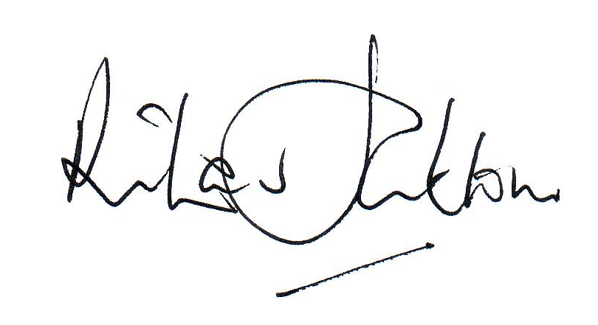  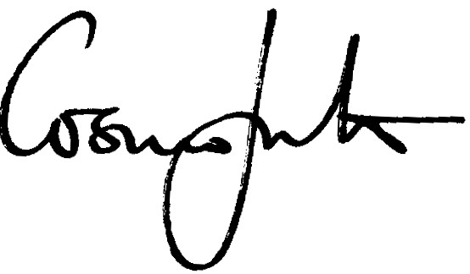
Date | 18th June 2024

Effective date of the policy | 1st September 2024
Circulation | Partners / all staff / parents / students on request

